**Ideation Phase**

**Brainstorm & Idea Prioritization Template**

|  |  |
| --- | --- |
| Date | 19 September 2022 |
| Team ID | IBM-Project-7476-1658858205 |
| Project Name | A Novel method for handwritten digit recognition system |
| Maximum Marks | 4 Marks |

**Brainstorm & Idea Prioritization Template:**

Brainstorming provides a free and open environment that encourages everyone within a team to participate in the creative thinking process that leads to problem solving. Prioritizing volume over value, out-of-the-box ideas are welcome and built upon, and all participants are encouraged to collaborate, helping each other develop a rich amount of creative solutions.

**Step-1: Team Gathering, Collaboration and Select the Problem Statement**

With the progress in the field of science and technology, everything is being digitized to reduce human effort. Hence, there comes a need for handwritten digit recognition in many real-time applications.

**Step-2: Brainstorm, Idea Listing and Grouping**

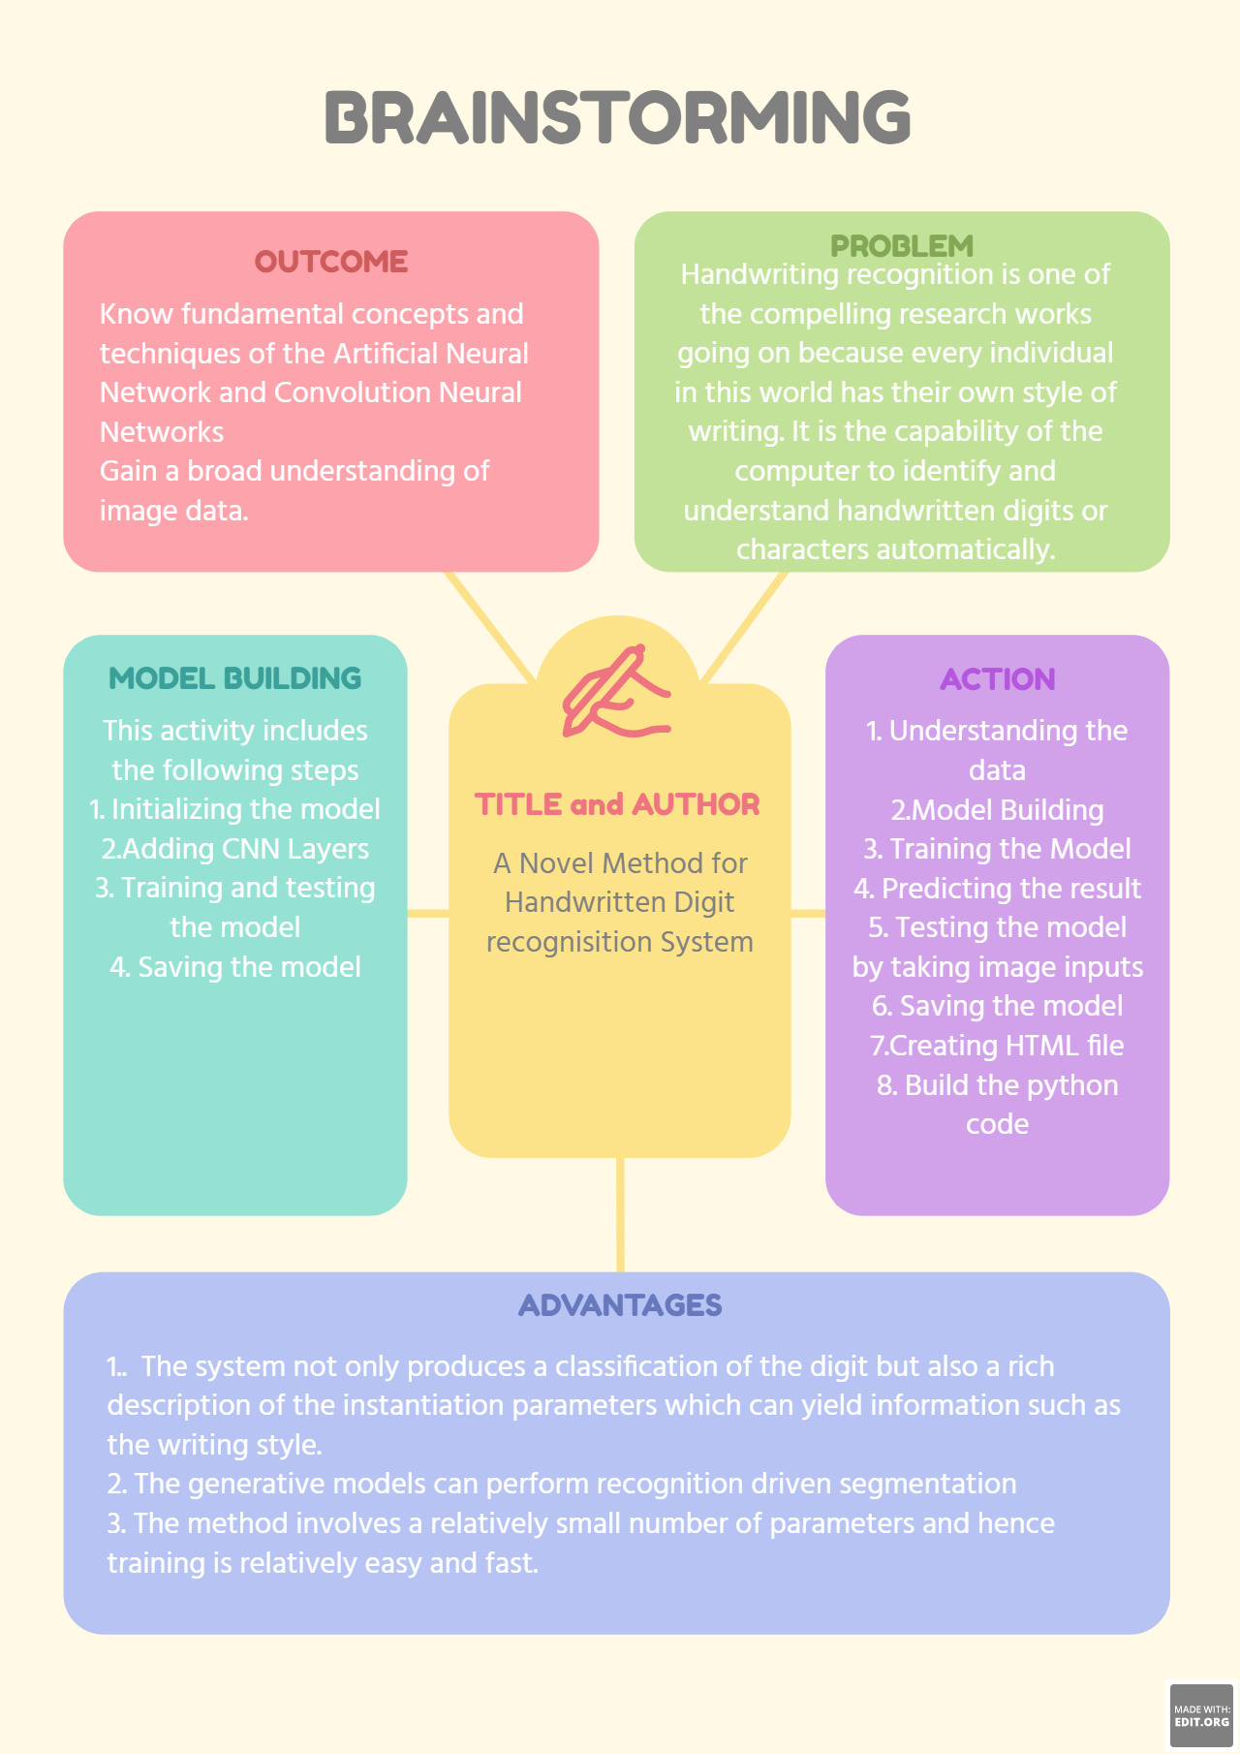

**Step-3: Idea Prioritization**

Handwriting recognition is one of the compelling research works going on because every individual in this world has their own style of writing. It is the capability of the computer to identify and understand handwritten digits or characters automatically. Because of the progress in the field of science and technology, everything is being digitalized to reduce human effort. Hence, there comes a need for handwritten digit recognition in many real-time applications. MNIST data set is widely used for this recognition process and it has 70000 handwritten digits. We use Artificial neural networks to train these images and build a deep learning model.

The main idea of the project is to,

* Initialise the model
* Adding CNN layers
* Training and testing the model
* Saving the model